Logging into Concerto and Raising a Job
- Logging into Concerto
We have secured access to Concerto with Single Sign On.
When you first use the concerto link: https://hiwfrs.concerto.co.uk/ you will see one of three possibilities
- You may be logged straight into the Concerto Home Page.
- You may be taken to the log in screen. Underneath the area to enter your credentials is a grey button which states log in with Hants Fire Network Credentials. If you are fire, select this button. If you are police, click the arrow next to this box and change the option to log in with Hants Police Network Credentials.
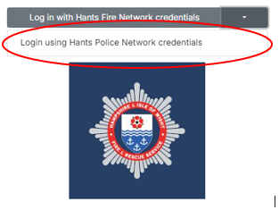
- You will be asked to update your Security question. Please ensure that you use something that you will remember.

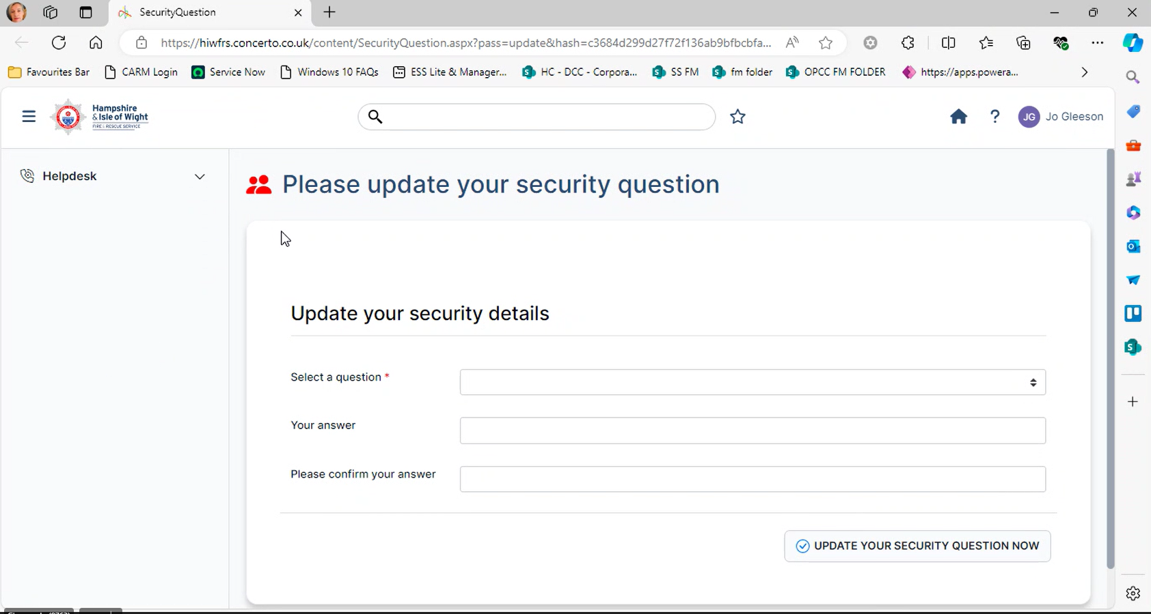
- When you have chosen the question and input your answer, select update your security question now and you will get the below message.

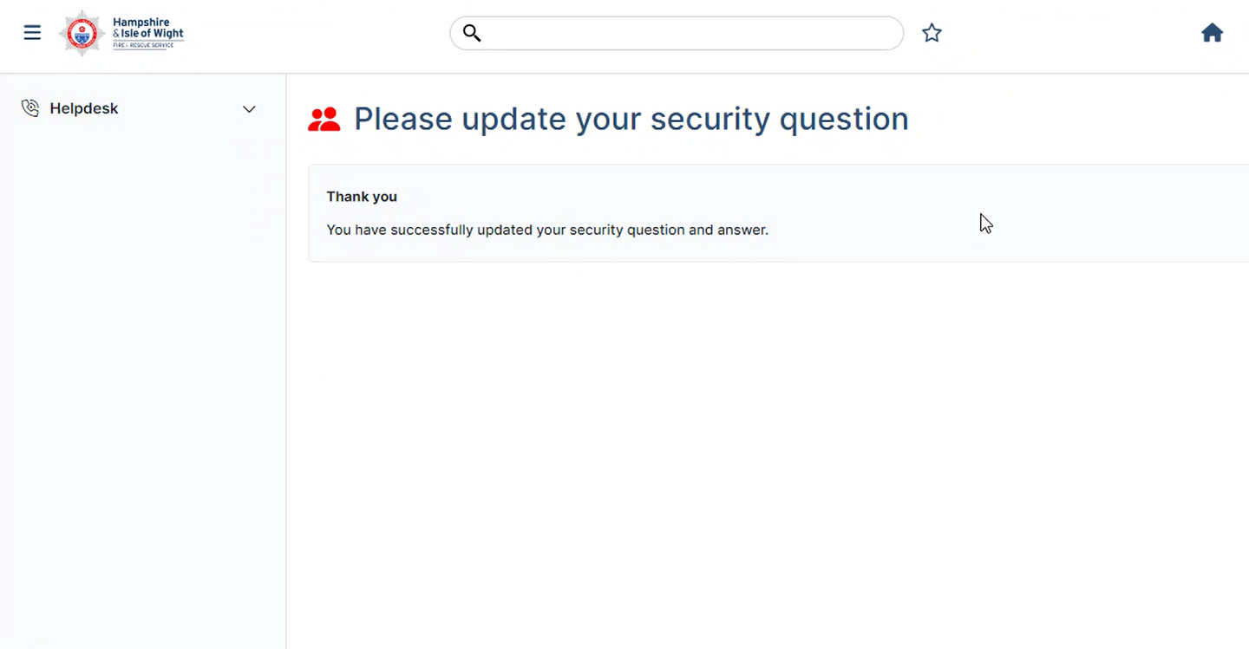
- You are now logged into Concerto.

Your concerto screen will look as below

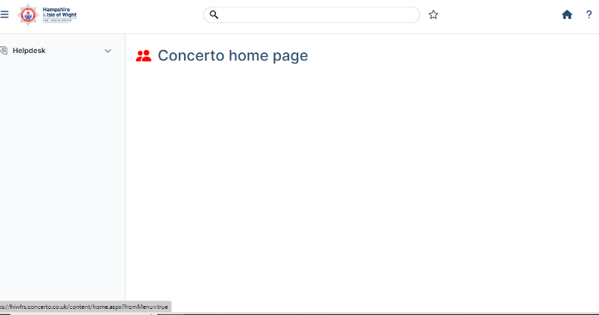

- Raising a job

- To raise a job, From the Concerto Home Page open the Helpdesk option on the left-hand side and select Raise job
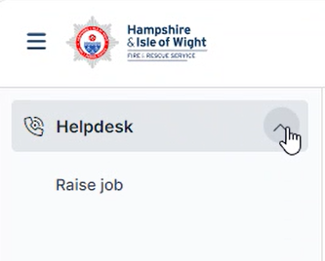

- Select the site you need to raise a job against by either typing the name in and hitting search, or choosing the site from the site list
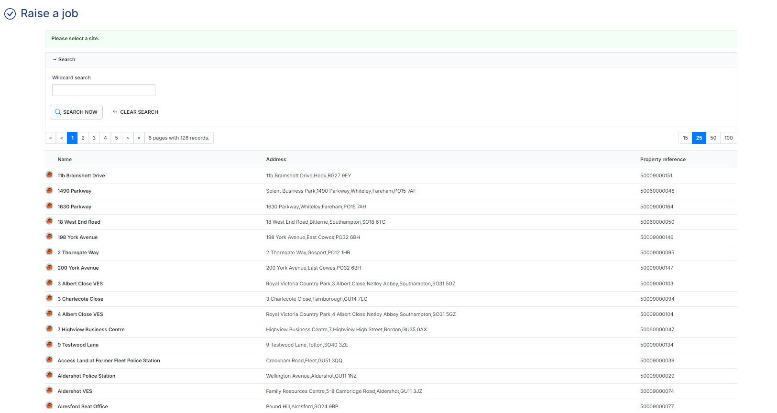

- Once you have selected the site, confirm the site is correct and select next
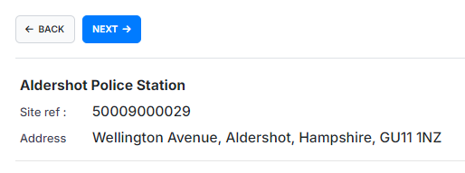

- If asked, select the block the fault relates too from the available options
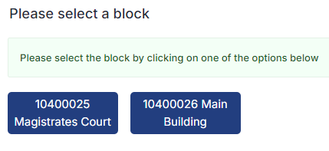

- Select the floor in question
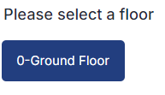

- Select a room location for the fault
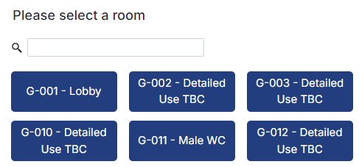

- Confirm if you are police or fire staff
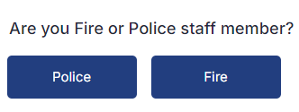

- Enter in the best contact number for you and select next
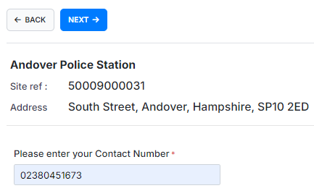

- You will now need to select a classification for the job – This is the category of what the fault is. 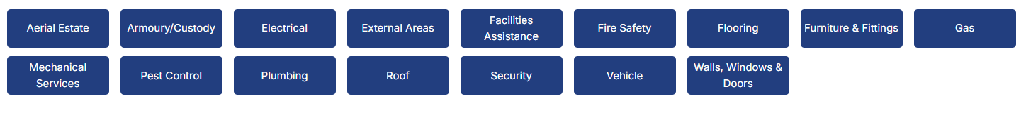

- Once you have completed choosing the classification, confirm if there is a Critical asset, Health and Safety or Security Concern
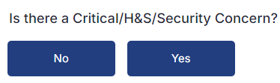

- You now need to provide information on the fault and location. Please be as descriptive as possible
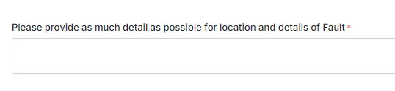

- When all information is added select next


- Upload any supporting documents or photos and select Next.

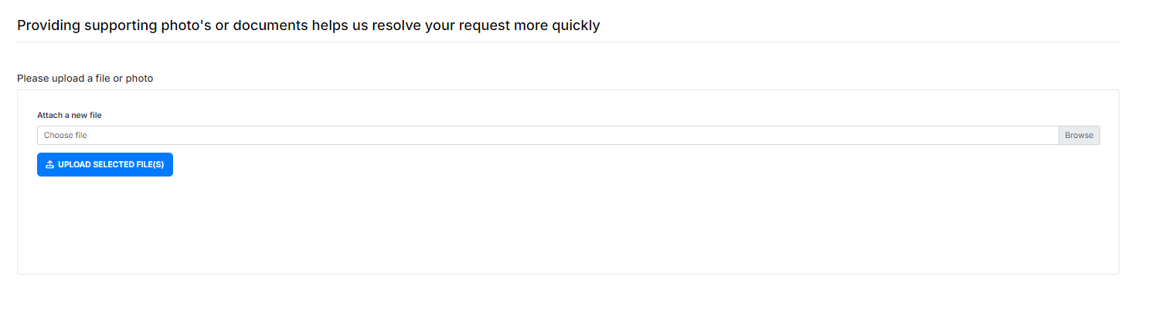

- You will be provided a job summary screen. Please read all of the information provided to confirm the details are correct and select confirm
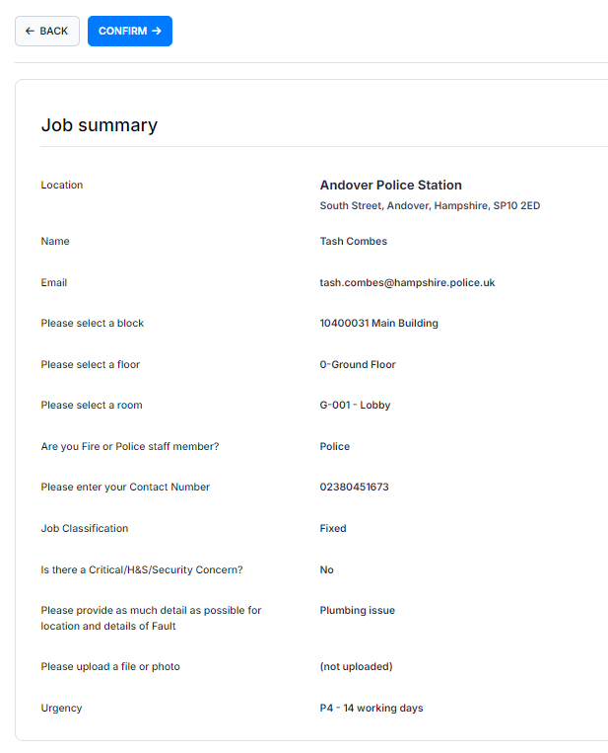

- You will be provided a reference number, and the job is now with the Service Desk to carry out.
- You will also receive an email confirming that your job has been raised.


